Day-20:

File Management:

Create, rename, or delete multiple files based on a pattern or criteria.

Organize files into a specific directory structure.

Back up or archive important files.

Text Processing:

Search and replace text within a group of files.

Extract specific information from log files or data sets.

Format text files in a particular way.

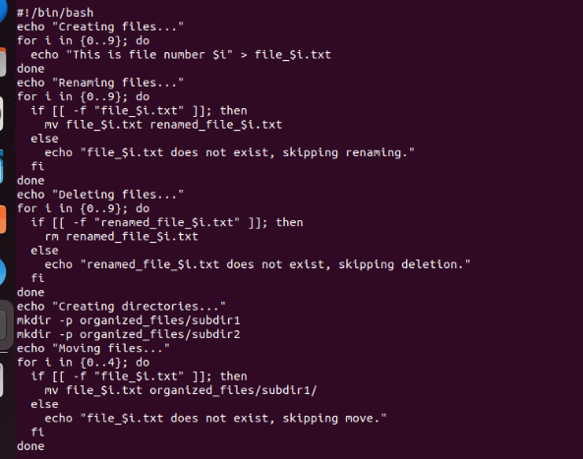

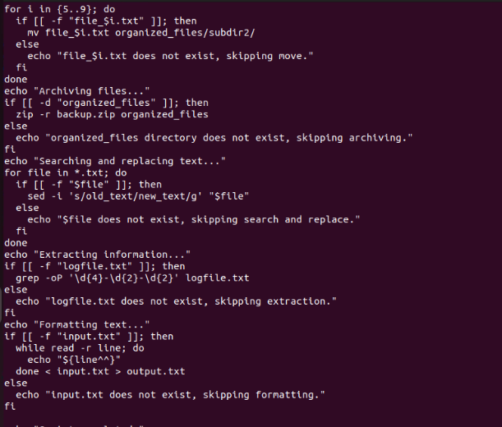

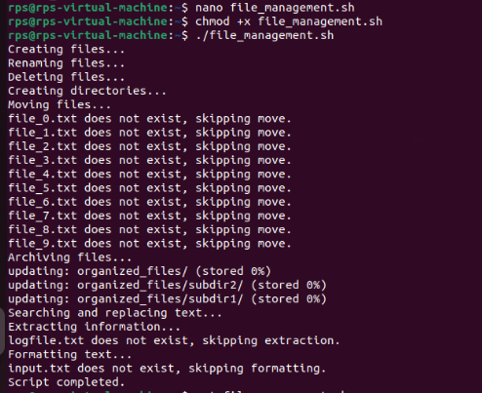

Exercise 3: Write a shell script called file_checker.sh that checks if a file exists or not. The script take in a file name as an argument and try to run cat on that file. The script should then check the exit code of the cat command to determine if the file exists or not. If the file exists, the script should print File exists!. If the file does not exist, the script should print File does not exist!. Bonus: change the script to suppress the actual output of cat and only include your script's output (e.g. File exists! or File does not exist!). give all commands from creating the file to end.

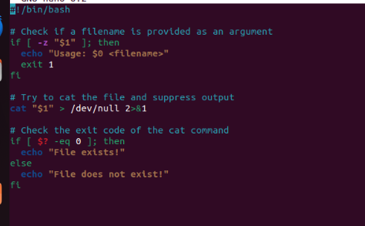

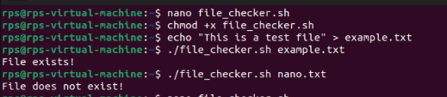

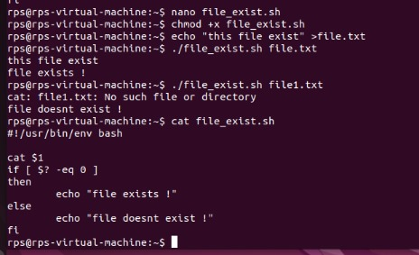

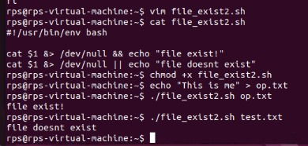

Write a shell script called

timely_greeting

.sh that greets

you based on the current time. The script should call the

date

command, extract the current hour (look into using

%H) and then print

the following greeting based on the time.

If it is between 5AM (05:00) and 12PM (12:00):

Good morning!

If it is between 12PM (12:00) and 6PM (18:00):

Good afternoon!

If it is between 6PM (18:00) and 5AM (5:00):

Good night!

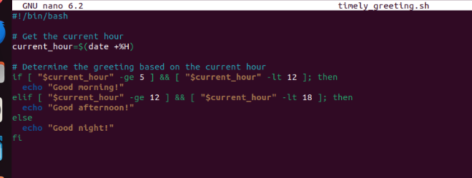

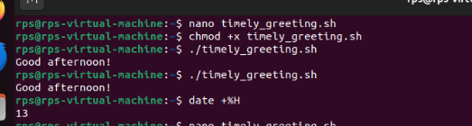

Perform add and substract and extend the script to include multiplication and division operations, and handle division by zero appropriately.

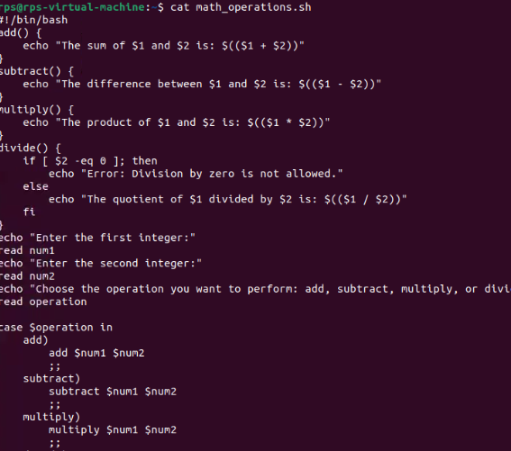

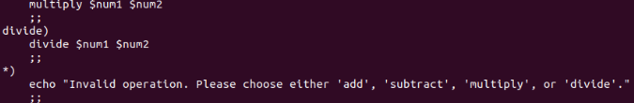

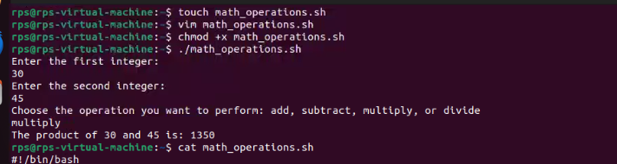

Write a code in shell perform operations Extend the script to include Addition, Subtraction, Multiplication and division operations, and handle division by zero appropriately.

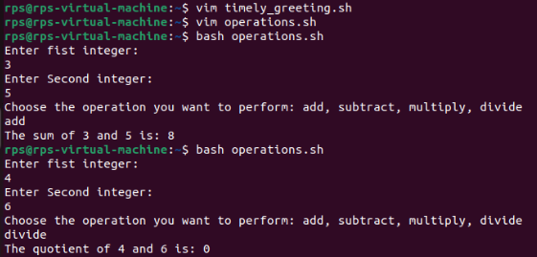

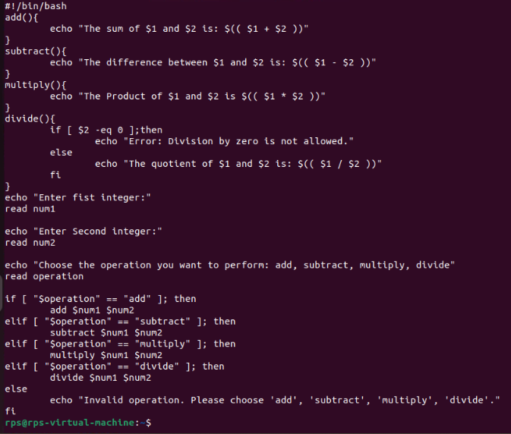

Title: Create, Write, and Read Files Using Shell Script

Objective:

Develop a shell script that can create a file, write user-provided content into the file, and then read and display the content of the file.

